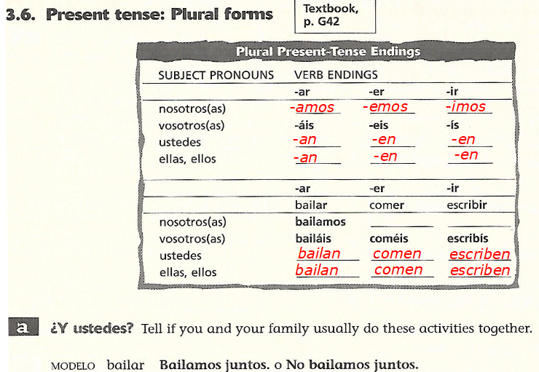
*Type your answers to the right of the infinitive.

- comer

- leer

- escuchar música

- ver la tele

- preparar la comida

- pasear en bicicleta

- salir a comer (to go out to eat; only the salir is conjugated )

- alquilar videos

- limpiar la casa

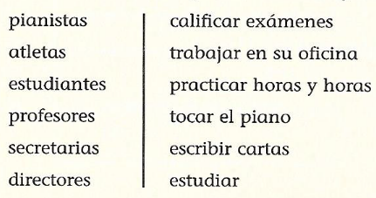

*Match the profession up with the action, conjugate the infinitive and type the complete sentence below. There will be one sentence per profession.

