Describing with colors, Chapter 2
A. La forma feminina Instrucciones: Write the feminine form of each adjective. Remember that some adjectives will not change (those that don’t end with –o).
1. rojo___________________________ _____ 2. anaranjado_______________________________
3. amarillo_____________________________ 4. verde___________________________________
5. azul________________________________ 6. morado__________________________________
7. rosado______________________________ 8. café_____________________________________
9. negro_______________________________ 10. blanco__________________________________
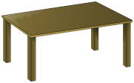
B. Escribir frases Instrucciones: Write a sentence describing each item, using the color given. You may need to change the adjective to the feminine version. Follow the model!
Modelo: + rojo La mesa es roja.
1. + blanco ___________________________________________________________
2. + verde __________________________________________________________
3. + azul ___________________________________________________________
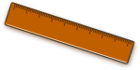
4. + rosado _________________________________________________________
5. + café ____________________________________________________________

