**Para practicar vocabulario Ch.2

Instrucciones: Label each item en español. *Use your interactive notebook as a reference!*

9. __________________

8. ________________

7. ____________________

6. __________________

5. ____________________

4. _______________________

3. _________________

2. _______________________

1. _______________________

B. ¿Cuántos hay? Instrucciones: Answer this question, using the illustrations to tell you how many items there are. **Spell out the numbers en español.** Pleaseuse your interactive notebook as a reference, for plurals and spelling. Follow the model.

***Modelo:*** ¿Cuántos niños hay?

***Hay tres niños.***

1. ¿Cuántos libros hay? 2. ¿Cuántos cuadernos hay?



_____________________________. _____________________________.

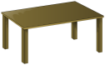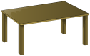3. ¿Cuántas mesas hay? 4. ¿Cuántas sillas hay?



_____________________________. _____________________________.

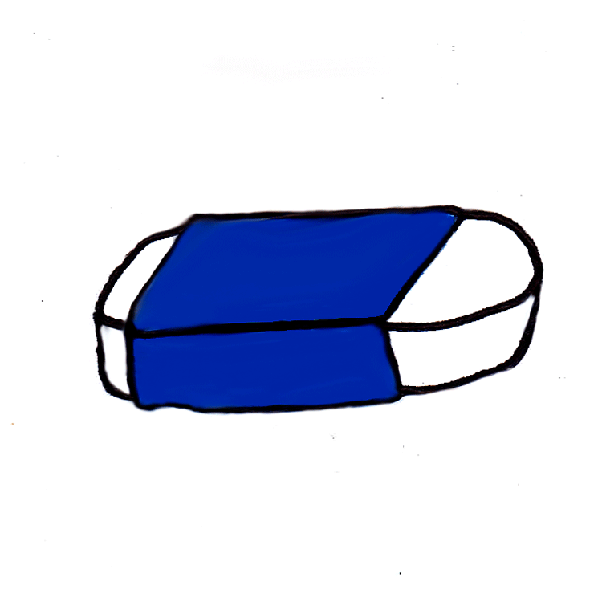5. ¿Cuántos papeles hay? 6. ¿Cuántos borradores hay?



_____________________________. _____________________________.

7. ¿Cuántos lápices hay? 8. ¿Cuántas luces hay?

_____________________________. _____________________________.