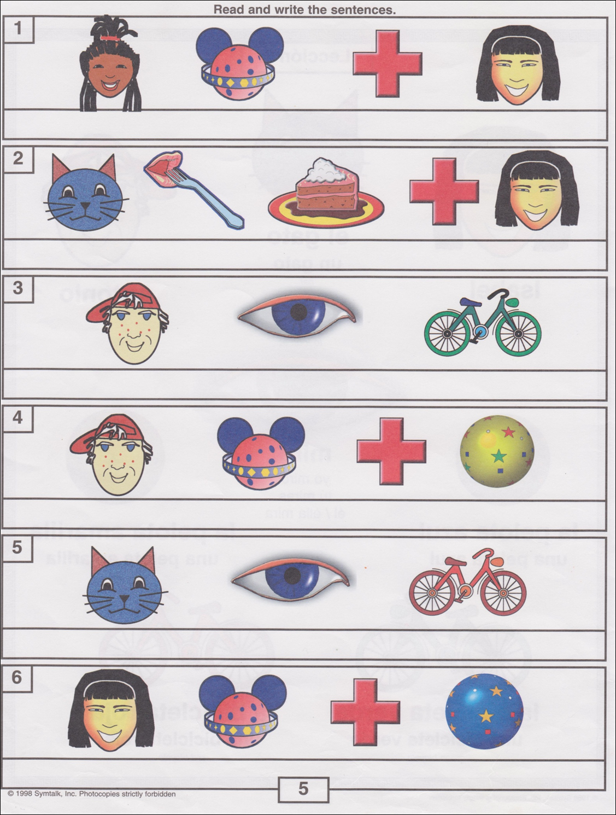Practice with Symtalk Lesson 2

**Adjectives are in ovals.**

amarillo

verde

azul

rojo

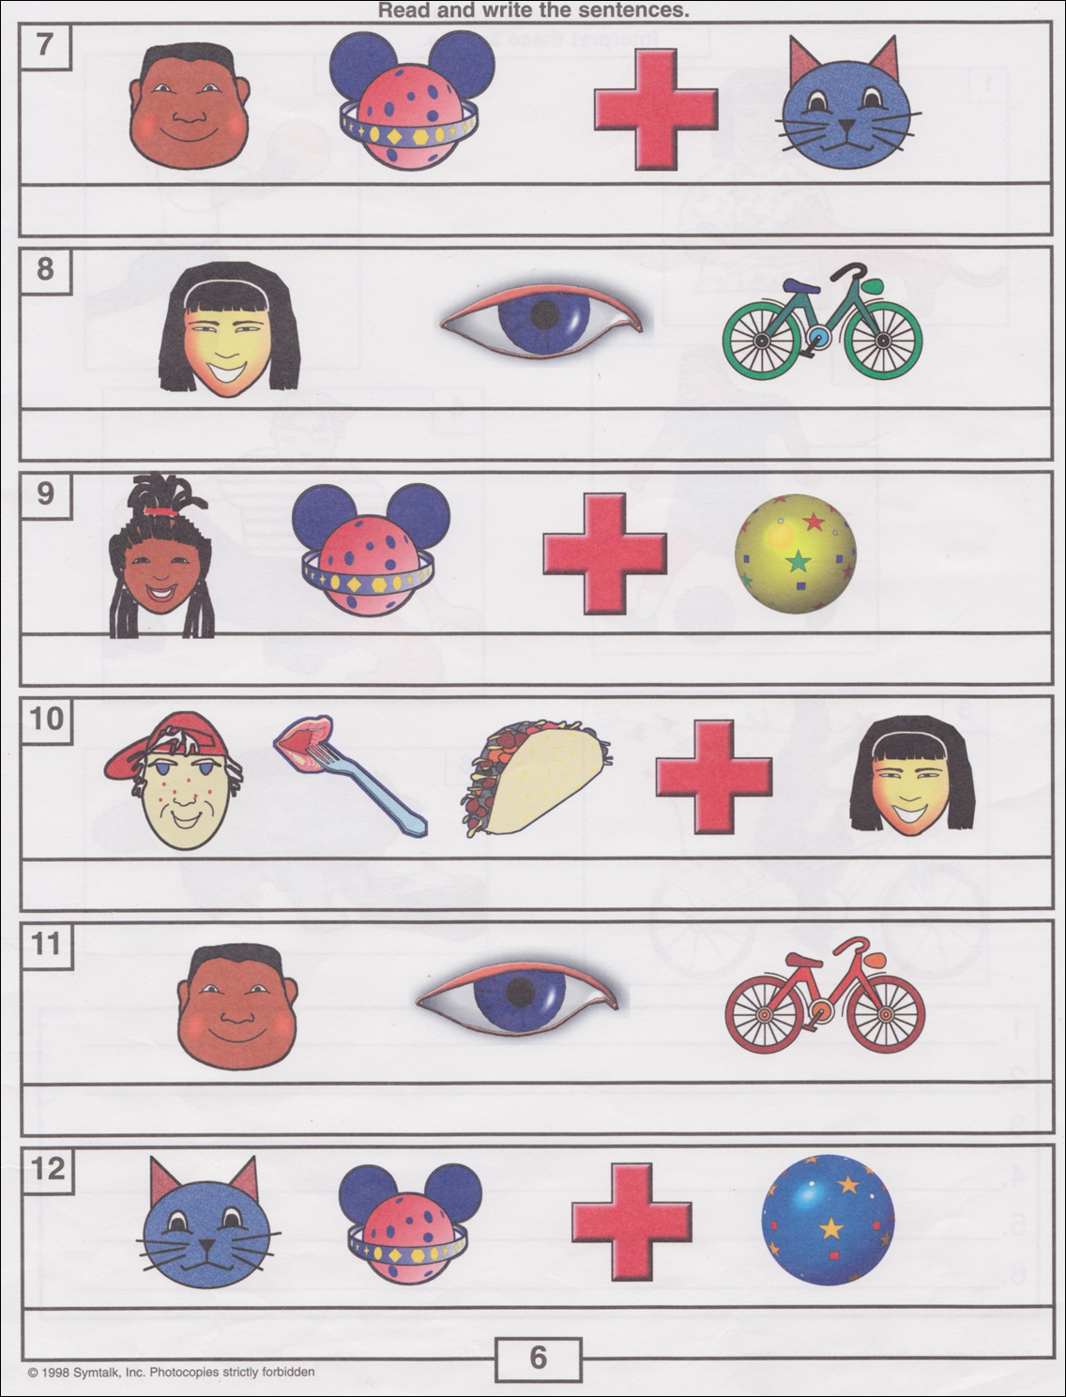

azul

rojo

amarillo

verde