Practice with Symtalk Lesson 3

**Write the sentences. Adjectives are in ovals.**

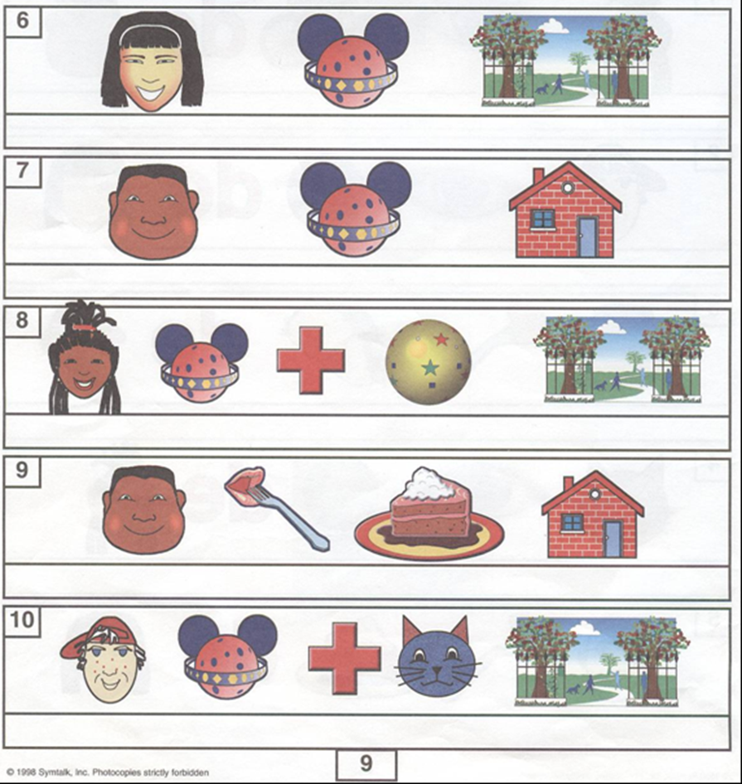

1.

5.

4.

3.

2.

amarillo

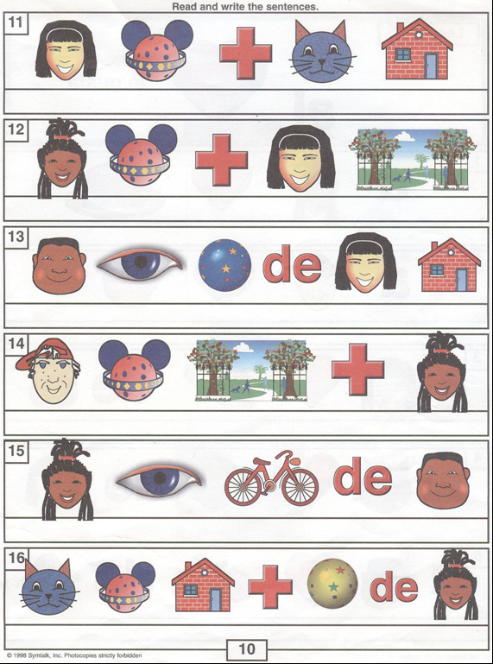

11.

10.

9.

8.

6.

7.

azul

rojo

amarillo

**Adjectives are in ovals.**