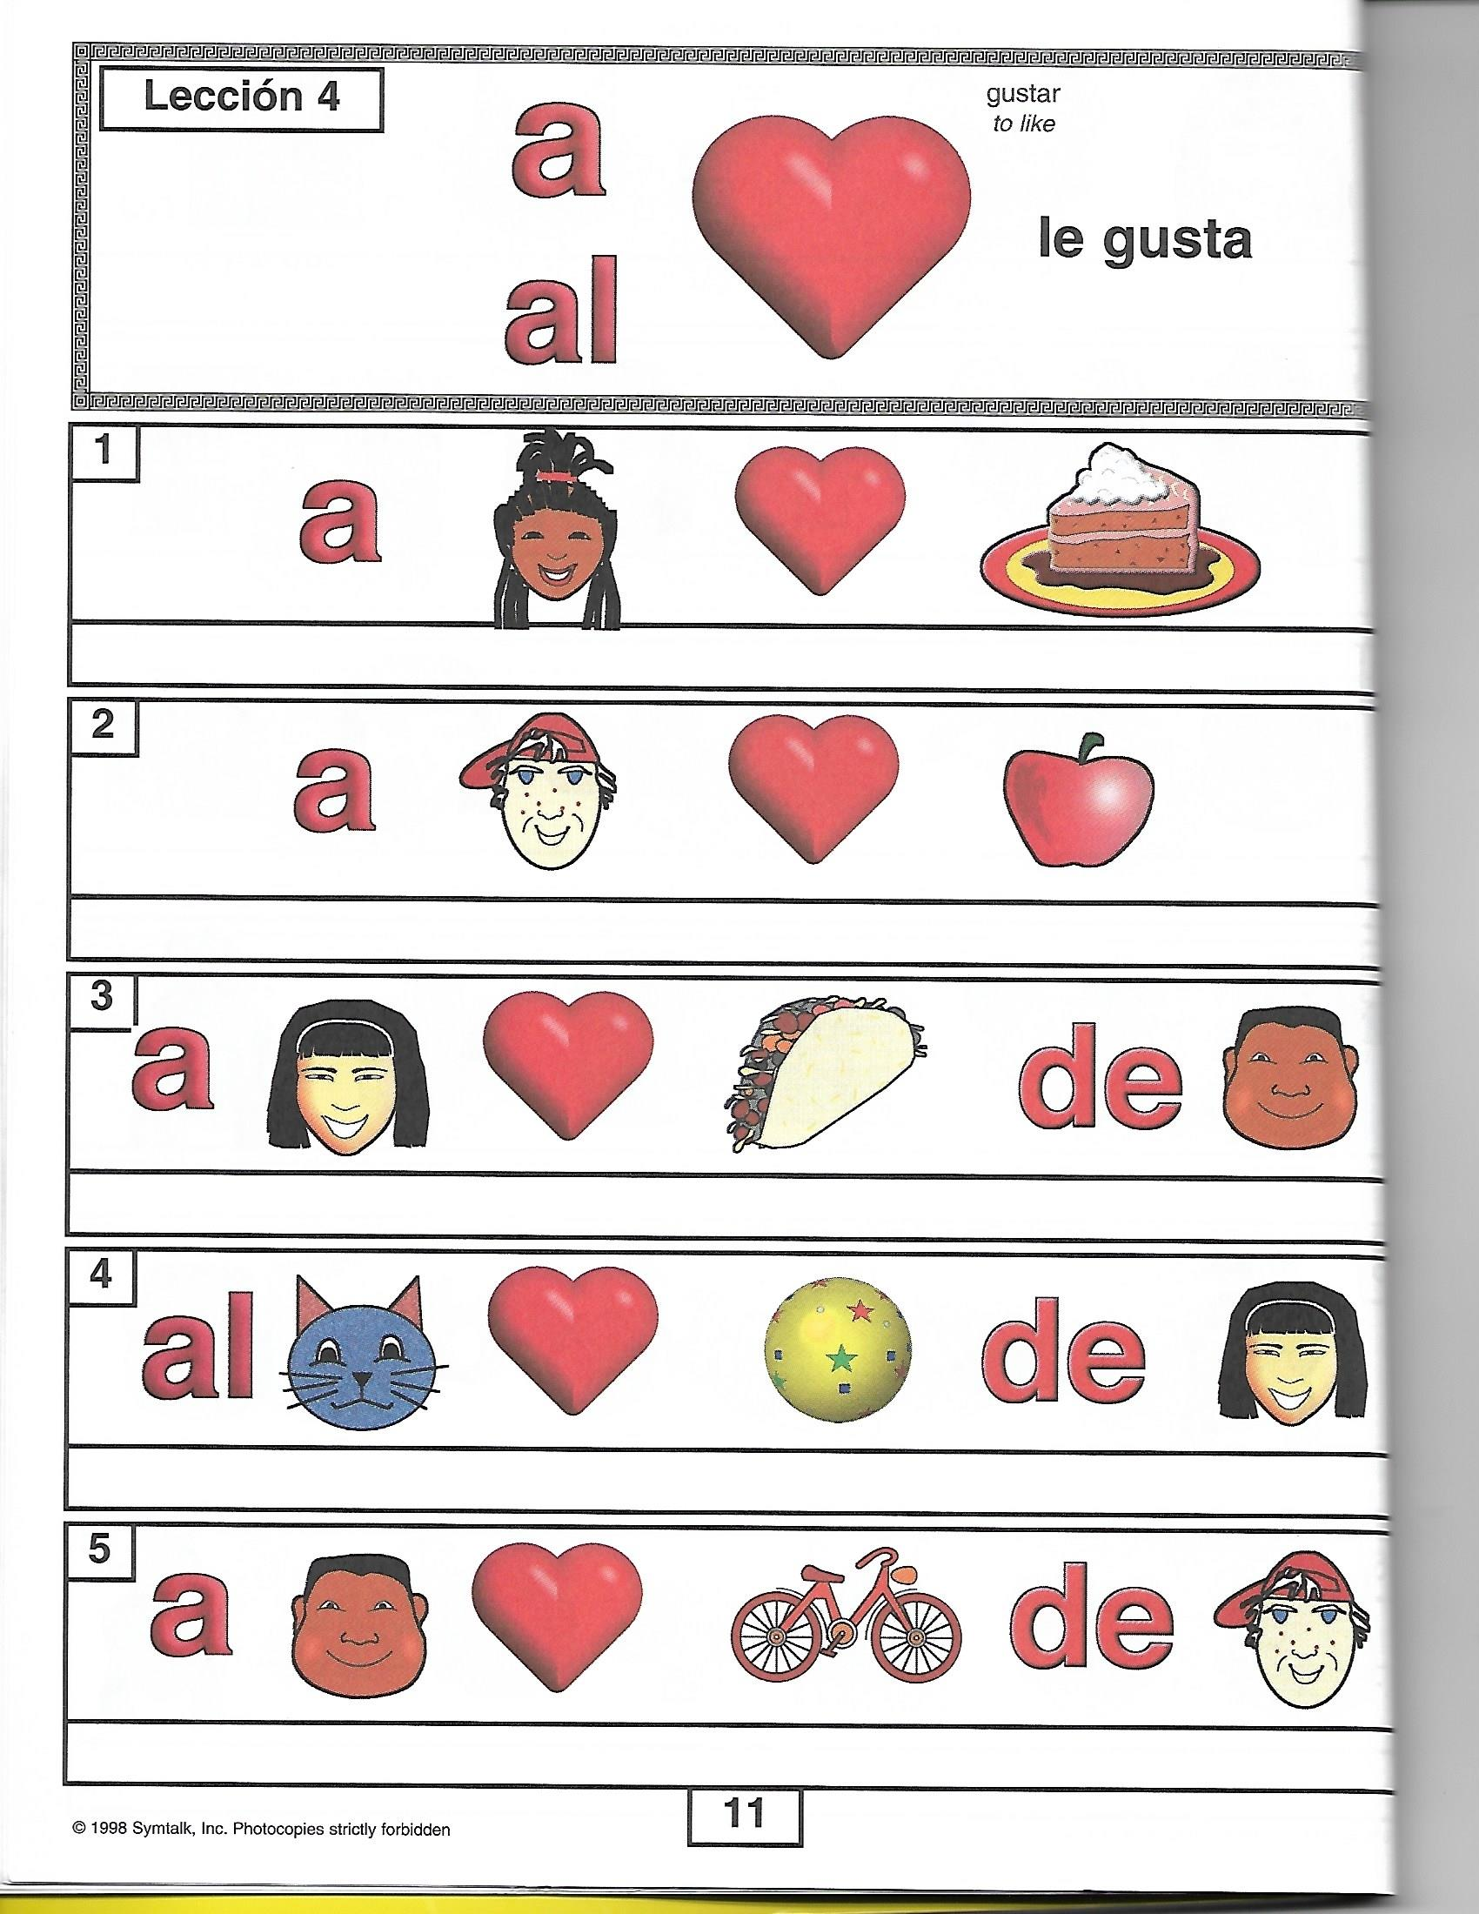Practice with Symtalk Lesson 4a

amarillo

**Write the sentences. Adjectives are in ovals.**

